Isolation of Measles virus from infected children in Babylon province
Dr. Ziton Abdulrida Ighewish Al-Khafaji
College of Medicine University of Babylon, Hilla, Babylon, IRAQ
Dr.Jaafar K. N. Al-Mousawi
University college for humintarian studies,Al-Najaf –Al-alashraf-Iraq
Dr. Youins A . K. Al-Khafaji
College of Dentistry, University of Babylon, Hilla, Babylon, IRAQ

Abstract:
Measles is an acute, highly contagious disease characterized by, fever, coryza, conjunctivitis , cough, and specific enanthema , (Koplik's spot) is consider to be pathognomic feature for measles. It occurs 1-2 days before rash onset and last to 1-2 days after rash onset and appears as, small, bright red irregular spots with bluish – white center, and rapidly increase over the entire bucal mucosa, and this disease is caused by measles virus infection which is one member of the family paramyxoviridae. Isolation of the virus from seven suspected case (recorded in obstetric and children hospital in Babylon governorate had been detected as measles virus infection by (IgM) ELISA test by central public health laboratory in Baghdad) on two type of cells culture, chicken Embryo fibroblast (CEF) and Vero cells-line.
The finding of this study revealed successful isolation process of the virus from one suspected case after its growing on the Vero cells-line and CEF and reached it maximum virus titer on Vero cells (3×10⁵ /0.1 ml TCID₅₀) after 7th passage where as maximum virus titer on CEF were (3×10⁴ /0.1 ml TCID₅₀) after 10th passage detected as measles virus by Neutralization as well as immunoflourescent tests.
Key words: Measles virus chicken embryo fibroblast, vero cells

عزل فيروس الحصبة في الاطفال المصابين في محافظة بابل
الخلاصة :
خمج الحصبة هو خمج معدي حاد يتميز بارتفاع درجة الحرارة ، زكام ،التهاب الملتحمة ، سعال وطفح خاص على الغشاء المخاطي يعتبر العلامة المرضية المميزة للحصبة والتي تظهر قبل يوم إلى يومين من بداية ظهور الطفح وتبقى ليوم أو يومين بعد بداية ظهوره كنقاط صغيرة لماعة حمراء غير منتظمة ذات مركز ابيض مزرق وسرعان ما يزداد عددها على طول التجويف الفمي .ويتسبب هذا الخمج عن الاصابة بفايروس الحصبة وهو احد أفراد عائلة ال .Paramyxoviridae
عزل الفايروس من سبعة حالات سجلت في مستشفى الولادة والاطفال في محافظة بابل تم الكشف عنها مختبر ياً باستخدام فحص الاليزا في مختبر الصحة العامة المركزي في بغداد على نوعين من الخلايا وهما الأرومة الليفية لجنين الدجاج (CEF) وخط خلايا جنين القردة الأفريقية الخضراءVero cells –line) )وقد أظهرت نتائج الدراسة نجاح عملية عزل الفايروس من أحدى العينات بعد تنميتة على خلايا الخط النسيجي لجنين القردة الأفريقية الخضراء (Vero cells –line ) وخلايا الأرومة الليفية لجنين الدجاج (CEF)حيث بلغ أعلى معيار للفايروس المعزول على خلايا الVero (3×10⁵/0.1 ml TICD50) بعد التمريرة السابعة في حين بلغ أعلى معيار للفايروس على الأرومة الليفية لجنين الدجاج×10⁴/0.1 ml TICD50) .(3 بعد التمريرة العاشرة وقد تم التأكد من الفايروس المعزول من خلال فحصي التعادل المصلي وفحص الومضان المناعي.
Introduction:
Measles is an acute, highly contagious viral disease capable of producing epidemic. It is unquestionably one of the most important sources of morbidity and mortality throughout the world (1).
Measles is chiefly a disease of childhood fairly mild in itself unless complicated by respiratory infection and also associated with a profound, transient suppression of cell mediated immunity (2) which contributes to the major complications of measles pneumonia, croup, sinusitis, otitis media, diarrhea and other secondary infections (3). However, in some cases it also cause encephalitis and persistant viral infection of central nervous system causing subacute secleroting panencephalitis (4).
In developing countries the disease mainly affects children under 3 years. The age at risk is even younger in urban areas: children under 2 years with a high proportion of under 1 years, are mainly affected (5). Measles remains one of the leading causes of child mortality in developing countries, responsible for approximately 30-40 million measles infection leading 1-2 million death measles which represent 10% of all death among children aged less than 5 years (6, 7) these death typically occur among children in countries with low vaccination coverage levels. Even countries that have achieved high levels of measles vaccination coverage and have recorded several years of low incidence frequently have experienced large measles outbreaks (8, 9). studies about incidence of measles infection in Iraqi population indicated that there was marked increase in measles cases during 1997 and also occur during the period of 1998- 1999 and according to the center of disease control reports, the total number of measles cases were 454 during the year 2003 and there was marked increase in the cases during the period extended from January till June 2004 and the total number of reported cases was 8253 especially in Basra and other southern governorate .
Aims of the study
Isolation of Measles virus from infected patient on two types of cell culture.
Materials and methods
A total of 217 blood sample were collected randomly from children ranged from 1-12 years old, during the period extended from January 2004 up to February 2005. Isolation process was performed on seven suspected Samples (blood & urine ) Isolation of the virus from seven suspected case (recorded in obstetric and children hospital in Babylon governorate had been detected as measles virus infection by (IgM) ELISA test by central public health laboratory in Baghdad).
Chemical and Reagents
A. Buffer Solution
1. Phosphate Buffer Saline (PBS)
Prepared according to method of (10) as follows:
Sod. Chloride | NaCl | 8.00 gm
Potassium chloride | KCl | 0.02 gm
Disodium hydrogen orthophosphate | Na₂HPO₄ | 1.15 gm
Potassium dihydrogen phospgate | KH₂PO₄ | 0.20 gm
Dissolved in one Litre of double distilled water and adjusted to pH.7.2 by 0.1 N HCl.
2. Trypsin Solution
Crystalin trypsin 1:250 (Difco) used for preparation of trypsin solution at a concentration of 0.25% in PBS pH7.2. The solution was sterilized by 0.22μm membrane filtration.
3-Tissue Culture Media Components
1. MEM (Eagles Minimal Essential Medium) (Sigma chemical corporation) Prepared as 10% concentration in de-ionized double distilled water for growth and maintenance cell culture.
2. Fetal calf serum (Flow Laboratories. England)
used in a concentration of 10% for growth media only.
3. Lactalbumin hydrolysate (Difco Laboratories. Detroit. Michigan) used in a concentration of 2.5 % and added to the growth and maintenance media at 10%.
4. Antibiotic (100 I. U. crystalin penicillin and 100μg Streptomycin)/ml of growth and maintenance media prepared)
Antibiotics were prepared by dissolving one million international units of crystalline penicillin and 1 gm streptomycin sulfate in 100ml of sterile double distilled water then distributed into 5ml volumes and stored at-20°C To each 100ml media, 1ml of this stock solution was added.
4-Versen (Ethylene Diamine Tetra Acetic Acid) (Fluka Switzer Land)
One hundred mg of versen was dissolved in 10 ml deionized double distilled water, autoclaved at 10 PSI for 15 minutes, distributed in 1 ml volumes, stored at 4°C and used as 0.4 ml of 1% solution added to 20ml of sterile PBS pH 7.2 to make final concentration of 1/ 5000.
5-Trypsin-Versen Solution : Prepared by mixing equal volume of trypsin and versen solutions and stored at -20 °C till used.
Methods
Cell Cultures: Cell cultures include the following:
A. Chicken Embryo Fibroblast Cell Cultures
The following method used for preparation of chicken embryo fibroblast cell culture and all steps carried out in sterile laminar flow:
1-After preparation sterile general material for tissue culture techniques (Scissors, Petri dishes, forceps, pipette, (1ml, 10ml), Gauze pads, small funnel, centrifuge tubes, sterile PBS with antibiotics, sterile small flask….etc.).
2-Nine days incubation eggs were candled to be sure of viability.
3-The shell over the air sac was disinfected with gearm iodine, then shell opened by tapping and cracks off the shell with sterile forceps.
4-The membrane pulled aside with sterile forceps and embryo lifted out by grasping the neck lightly between the forceps and clipping away membranes which attach the embryo to the yolk, and the embryo placed into a sterile Petri dish and washed with sterile PBS pH7.2 containing antibiotics to remove blood.
5-The head and eternal organs were removed from embryo and only the body was processed for cell culture, simply by putting the embryo inside Petri dish, then cutted into small pieces of about 1 to 2mm, after that washed with sterile PBS pH7.2 then pieces of tissue transferred to sterile small flask containing sterile magnetic stirring bar. after that 20ml of PBS was added, the flask was swirled and large pieces allowed to settled whereas the cloudy supernatant which contains cell debris, blood, connective tissue was discarded, this step repeated again to remove all undesired materials.
6-Then prewarmed (37°C) sterile trypsin (0.25%) was added in sufficient quantities (about 10 time the volume of solid materials).
7-The flask placed on stirring hoat plate, the suspension was stirred for about 15 minutes at relatively rapid speed but without formation of foam.
8-After 15 minutes the flask removed from stirring, and supported at an angle so that settlement of large particles occur, the supernatant was filtrated through 4 layers of sterile gauze pads and cells suspension collected in sterile container, then sufficient amount of cooled sterile growth medium was added to stop the action of trypsin.
9-Trypsinization, spinning, filtration and addition of cooled growth medium repeated 3 to 4 times more and the remnants was discarded.
10-The collected filtrated cells suspension was distributed in sterile centrifuge containers in equal quantities, closed tightly and centrifuged at 1500 rpm for 10 minutes at 4°C (Baird and Tatlock cooled centrifuge).
11-The supernatant fluid was discarded and sediment cells was re-suspended again in fresh sterile growth medium (each ml of cells dispersed in 150-200ml of growth medium), the pH of growth medium was corrected with sodium bicarbonate to reach (pH 6.8-7), then cell suspension was distributed aseptically in sterile disposable 25 cm² falcon flasks and incubated at 37°C till complete monolayer cell culture seen through daily inspection.
B. Secondary Chicken Embryo Fibroblast Cells Culture
The primary chicken embryo fibroblast monolayer was checked under an inverted microscope for quality and absence of microbial contamination. The medium and non adherent cells were decanted, then the cells layer was washed twice with sterile PBS pH7.2. After that trypsin and versen mixture solution was added to the surface of monoloyer cell culture at 37°C and by gradual pealing of cells from the surface of the flask shown with frequent examination and after complete detachment and dispersing of the cells which is facilitated by tapping the side of the flask with hand. The cells were suspended in growth medium to stop the action of trypsin then distributed in proper containers or microtiter-plates. The cell type, passage number and date were written on the side of the flask, then incubated at 37°C, tile complete confluent monolayer, the medium changed and used for virus passage and maintenance medium then added.
C. Vero Cells – Line
This cells were originally obtained from central public Health Laboratory (Baghdad). The cells were grown in growth media, Eagle's minimum essential medium (MEM) with glutamine and supplemented with 10% fetal calf serum, 10% lactalbumin hydrolysate, 100 I. U. penicillin and 100μg streptomycin/ml.
The maintenance medium was MEM without calf serum. The cells were sub-cultured by the same procedure as in (B) and grown in 25cm² Nunc flask or microtiter plates for detection of virus growth or performancy of indirect immunofluorescente antibody technique for estimation of virus antigen.
Virus Isolation
A. Virus isolation on primary chicken embryo fibroblast cell culture:
The isolation process of measles virus was performed on chicken embryo fibroblast cells and had been carried as follows: The clinical samples (Blood and urine) collected during the second days of rash onset from patient. The serum was separated aseptically and filtrated by 0.22μm membrane filter where as urine was stored at -20°C tile used in isolation process. The sterile serum samples were inoculated on complete monolayer of primary chicken embryo fibroblast cells culture, each samples on 3 falcons of 25cm² each falcon inoculated with 0.5ml of suspected serum sample and two falcons were inoculated with sterile PBS pH7.2 as control, then all falcons incubated at 37°C for 1 hour for virus adsorption, after that excess amount of inoculums was removed and maintenance media was added to falcons and incubated at 37°C and daily checked under inverted microscope for detection of any cytopathic effect. When CPE reach about 50-75% of the culture falcons were freeze at
-20°C and thawed 3-5 times for re-passage with the same procedure.
Frozen urine was thawed and centrifuged at 200 g for 10 minutes then filtrated by 0.22 μm membrane filter and inoculated on tissue culture by the same manner performed above.
B. Vero cells-line was inoculated by the same minor for primary chicken
embryo fibroblast cells for isolation and propagation of the virus.
Results
Virus Isolation
The isolation process was performed on seven suspected Samples (blood & urine ) , that were confirmed as being measles infection clinically & by ELISA test, only one sample gave positive result for virus isolation on both types of cell culture , the primary chicken embryo fibroblast (CEF), and Vero cell – Lines which were also used for virus propagation .
Both cell types show no cytopathic effect on first passage except that few cells of Vero cells shown vacculation of the cytoplasm at 7th days post inoculation, however cultures were frozen at 12th days post inoculation with suspected materials.
During the 2nd passage the number of cells showing vacculation were increased, whereas sporadic cells of CEF showing slight vacculation of cytoplasm in comparison with control cell culture . The number of infected cells increase with increased passages and Later on during the 5th passage CPE represented by foci of rounded cells with appearance of small cyncytia start to appear. This CPE consist of formation of multinucleated giant cell are developed which was usually observed as 50 or more nuclei bounded by a single cytoplasmic membrane. Some infected Vero cells showing dendritic appearance (Figure 1-B and 2-A) with increase of their refractivity to light without fusion . On the other hand this CPE appear much more rapid with increase passages and can be detected after 2nd or 3rd day post inoculation of Vero cells in the 7th passage (Figure 1-A) where as control cell culture showing normal appearance (Figure 1-C) .The CEF cell cultures some what showing slower adaptation of the isolated virus and CPE characterized by formation of multinucleated syncytia containing numerous nuclei of fused cell (Figure 2-B) which appear more clear and virus reach a titer of 3×10⁴ TCID₅₀ / 0.1ml on day 6 of the 10th passage while control cell showing normal appearance (Figure 2-C) . However CPE was generalized to involve larger area of the cells sheet followed by cell flotation and loss from the surface of infected flask with a total virus production of 3 × 10⁵ TCID₅₀ /0.1ml on Vero cell of 7th passage which was higher than that detected by CEF .The isolated virus was stored at -70 ْ C for further use.
Detection of Measles Virus in Cell Culture
The demonstration of specific measles virus antigen in infected cell cultures at each passage was accomplished by indirect fluorescent antibody technique (IFAT) of infected cell on a micro titer plate wells which had been carried out after 48 or 72 hours post inoculation.
A few fluorescing cells were readily detected in 3rd passage (Figure 3-A) comparison with control (Figure 3-B). However fluorescing cells were readily observed in all cell culture examined at the 7th passage and further passage as bright cytoplasmic as well as nuclear fluorescence and occupied most of the cells in sever extensive infection of the later passages as the incubation progressed. The virus had been also detected by performing the serum neutralization test with hyper immune serum which revealed presence of the virus.

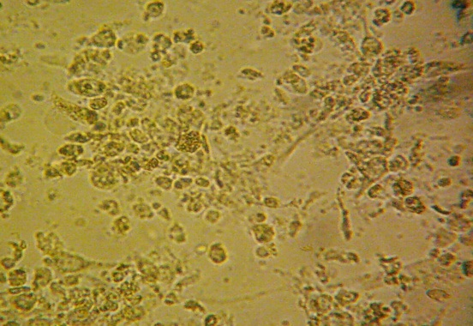
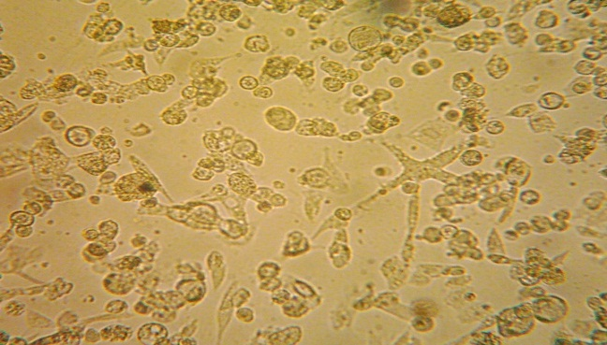

Figure (1-A):Cytopathic effect of measles virus on Vero cells -line after (72) hour post inoculation of the 7th passage (X-125).

Figure (1-B): Cytopathic effect of measles virus (dendritic form) on Vero cells -line after (96) hour post inoculation of the 7th passage (X-125).

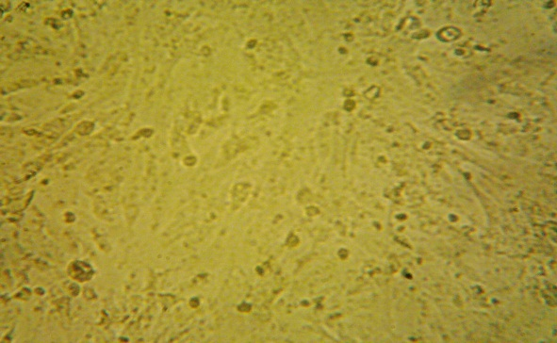
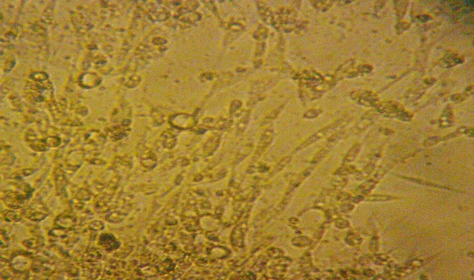

Figure (2-A): Cytopathic effect of measles virus (dentric form) on chicken embryo fibroblast cells after (72) hour post
inoculation of the 7th passage (X-125).

Figure (1-C): Uninfected control Vero cells –line after (72) hour
(X- 125).

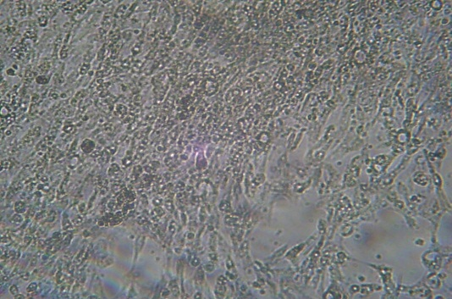
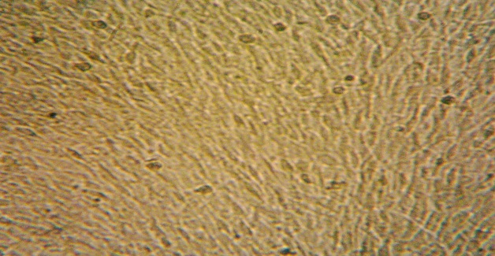
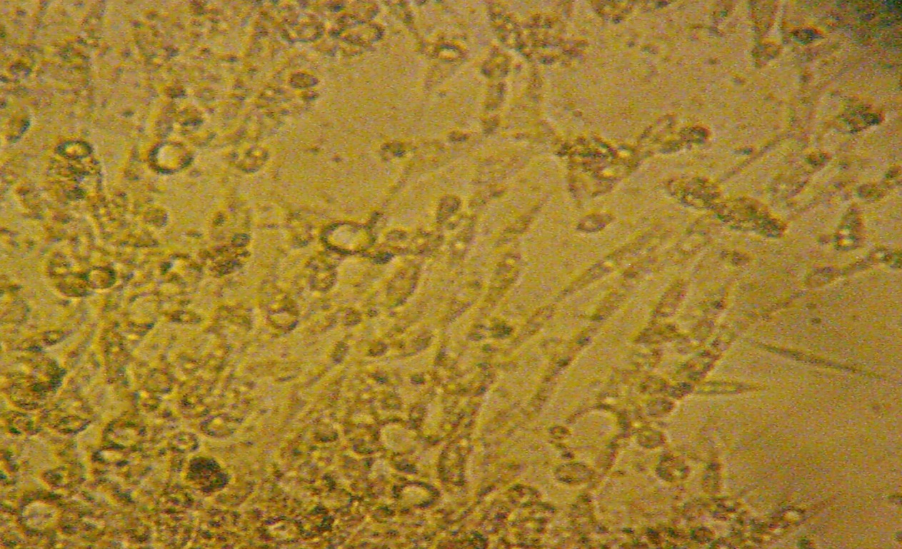

Figure (3-C): Uninfected control chicken embryo fibroblast cells
after (72) hour (X- 125).

Figure (3-B):Cytopathic effect of measles virus on chicken embryo ibroblast cells (Giant cell) after (72) hour post
inoculation of the 7th passage (X-125).

Figure (3-B) : Non infect cell culture stained by IFAT.

Figure (3-A): Measles Virus in infected cells stained by IFAT.

Discussion
The incidence of measles had decreased sharply since the introduction of live attenuated measles vaccine within the expanded program of Immunization (EPI) which was started at (1980) and significant advance in reducing morbidity and mortality from measles occur (11). But measles continues to be seen in Iraq in unimmunized individuals and in those who fail to seroconvert after immunization.
Measles infection in an individual with impaired immune function can be difficult to recognize even for the experienced observer (12). However persistent measles transmission in a community is attributed to the accumulation of susceptible person who include immunized children who are not protected due to primary vaccine failure or waning immunity , unimmunized persons or children too young to be immunized (13). The isolation and identification of the virus from suspected cases, followed by propagation of the isolated virus. The results shown that both Vero cell line and chicken embryo fibroblast (CEF) were capable to support the isolation and propagation of measles virus from suspected material. This was proved through detection of (CPE) induced by isolated virus on tissue culture of both cell type. We had been used (CEF) for isolation of the virus because it is easly to be prepared, cheep and other researchers had been succeeded to isolate and attenuated the measles virus on it.
Vero-cells line was better than (CEF) in isolation and propagation process. This had been proved through detection of clear (CPE) during the (5th) passage in comparison with (CEF) which gave clear (CPE) at the (7th) passage of the isolated virus, in addition (CPE) appear (48-72) ours post inoculation of the (7th) passage. Whereas (CPE) appear (6th) days post inoculation of the (10th) passage of the virus on (CEF). This finding in agreement with the result of (14), whom reported that measles virus rapidly adapted to Vero cells in comparison with (CEF).
This is due the fact that Vero cell possesses CD₄₆ receptor necessary for measles virus hemagglutinine attachment. CEF were poorly permissive to the infection by the isolated virus but progressive passage of the virus on it, initiate the adaptation process during which, the envelope glycoprotein's have been selected for efficient entry of the virus into CEF, as measles virus entry into cells requires a precise dynamic molecular scaffold involving the binding of hemagglutinine to the receptor, an appropriate pairing of H and F glycoprotein and conformational change in receptor, H and / or F protein (15, 16)
The ability of MV to bind to CEF not required CD₄₆ receptor but due to an endogenously synthesized protein and dose not require
N-glycosylation for its interaction with measles virus. This putative MV receptor on CEF differ from CD₄₆ and interacts with H protein by determinants distinct from those implicated in H interaction with CD₄₆ (14). The successful isolation process of measles virus explain that measles virus transmission still present in Iraqi population. This may be due to persistent measles virus transmission among children < 1 year of age or ≥ 6 years of age who were not targeted during mass immunization campaigns. The susceptible children introduced annually into population especially refuges may also explain the relative appearance of measles cases.
Conclusion
Vero cells-line can be used successfully for MV isolation.
We have concluded that successful isolation process of measles virus from suspected cases represent a good indication system of persistence of the MV among Iraqi population.
Recommendation
Isolation measles virus must be sequencing for knowledge of whether it is wild strain or vaccine strain.

References:
- Tayil, S. E. El-Shazly M. K., El-Amrawy, S. M., Ghouneim F. M., Abou Khatwa S. A. and Masoud G. M, (1998). sero-epidemioloical study of measles after 15 years of compulsory vaccination in Alexandria, Egypt. Eastern Mediteiranean Health Journal, Vol.4, No.3.
- Griffin D and Bellini W (1996). Measles virus. In: Field BN, Knipe DM, Howley PM, Chanock RM, Melnick, JL, Monath TP, Roizman B, and Straus SE, editors. Fields virology. Philidelphia-New York: Lippincott-Raven, 1267–1312..
- Larke RPB. Impact of measles in Canada. Rev Infect Dis 1983; 5: 445-51.
- Latif , I. I., (2002). Measles vaccination among seropositive individuals: an in vitro and in vivo virological and Immunological study. A thesis submitted to the council of Sedum College of medicine, Saddam University.
- Rigal J. and Szumilin E., 1999. Clinical guidelines Diagnostic and treatment manual. Fourth Edition.
- Grant JP. The state of the worlds children-1991. New York: United Nations: Children's fund.
- WHO, (1994). Expanded programme on immunization accelerated measles strategies. Wkly Epidemiol Rec. 69: 229-34 WHO/EPI/ 97. 04: 1-82.
- Chen RT, Weierbach R, Bisoffiz, et al., (1994). A "Post-honeymoon period" measles outbreak in Muyinga sector, Burundi. Int J Epidemiol. 23: 185-93.
- Pan American Health organization . Up date: measles in Candad, 1995. EPI Newsletter 1996; 18: 3-4.
- Grist,N R. ; Ross, C. A. and Bell , E. J. (1979) . Diagnostic methods in clinical virology. 7th ed., Kamp Hullbindery Oxford.
11-Ahmed FR, (1990). Epidemioloical and clinical study of measles cases admitted to IBN Al-Khateeb hospital during 1980-1989. 31-70 (thesis).
12-Martin B. Kleiman, Carol K. L. Black Burn, Sarah E, Zimmerman , and Morris L. V. French. (1981)Comparison of Enzyme-Linked Immunosorbent Assay for Acute Measles with hemagglutination Inhibition, complement fixation, and fluorescent- Antibody Methods. Journal of clinical Microbiology, Aug. P.147-152.
13- Orenstein WA, Markowitz L, Preblud SR, Hinman AR, Tomasi A, Bart KJ(1986). Appropriate age for measles vaccination in the United States. Dev Biol Stand.;65:13-21.
14- Escoffier C.and Gerlier D. ,(1999).Infection of Chicken Embryonic Fibroblasts by Measles Virus : Adaptation at the Virus Entry level.J.Virol., Vol.73,No.6,P. 5220-5224.
15- Buchholz,C.J.,U. Schneider,P.Devaux, D.Gerlier, and R.Cattaneo,(1996). Cell entry by measles virus: long hybrid receptors un couple binding from membrane fusion. J.Virol.70:3716-3723.
16- Gerlier,D.,and P.Devaux .(1997).CD46 unpremier recepteur du virus .de la rougeole.Virologie 1:321-330.

